

**Assignment No: 01**

**Dated:10-11-2022**

**Topics:** Water Fall Model? Its Pros and Cons?

Software Development Life Cycle?

Use Case and Domain Model?

Non-Functional Requirements?

**Subject Name:** Introduction To Software Engineering

**Teacher Name:**  Sir Shakir Rasheed Khan

**Student Name:** Saad Ishaq

**Registration No:** 4355-FBAS/BSSE/F21-B

**Department of Software Engineering**

**Faculty of Basic&Applied sciences**

**Question No: 1**

**Describe the Waterfall Model and list the stages of water fall model also list three advantages and disadvantages of this model?**

**Solution:**

The water fall model was the first process model to be introduce. It is very simple to understand and use. In a water fall model each phase must be completed before the next phase can begin and there is over lapping in the phase. The water fall model is a sequential design process in which process is seen as flowing steadily downward (like water fall).

The stages of water fall model are given below:

• Requirements

• System design

• Implementation

• Integration and Testing

• Deployment of system

• Maintenance

**Advantages:**

* Simple, easy to understand and use.
* Well understood milestones
* Process and results are well documented

**Dis-advantages:**

* No working software is produced until late during the life cycle
* High number of risks and uncertainty
* Poor model for long projects

**Question No: 2**

**List the stages of the software development lifecycle (SDLC). Describe each case in 1 phrase each?**

**Solution:**

The following are stages of software development lifecycle:

1. Ideation:

Brainstorming ideas that solve a particular problem faced by target users.

2. Requirements:

Interacting with stakeholders and users to collect and document project requirement.

3. Design:

Creating the architecture of a software system and its elements.

4. Development:

Building the software using a programming language by the development team.

5. Testing:

Evaluating the quality of a software with the aim of finding and fixing defects.

6. Deployment:

Preparing the software to run and operate in a specific environment.

7. Maintenance:

Updating and supporting the software after it has been delivered to the market.

**Question No: 3 Solution:**

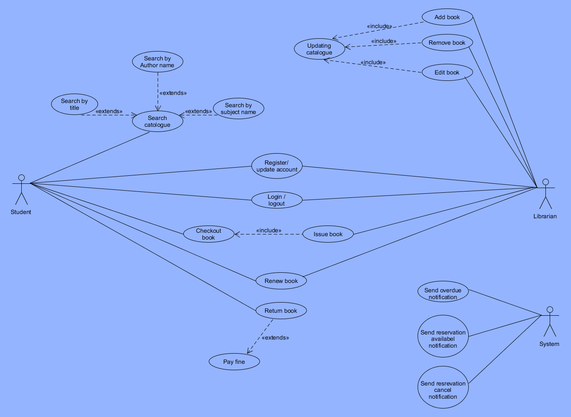

**Question No: 4 Solution:**

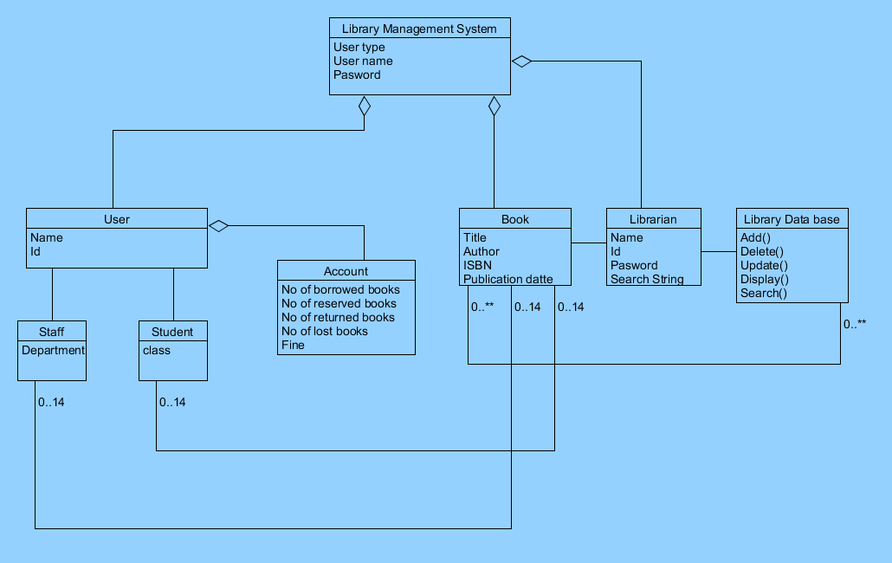

**Question No: 4  
Write the non-functional requirement for the following 2 projects?**

1. An online banking system:

• Security  
• Performance

• Usability  
• Availability

1. Bike racing game:

* Game should load within a second.
* Game should have realistic 3D characters.
* It should work very fast with out any buffer.